AP Calc WS#10 Derivative of Product and Quotient Name: ______

*Differentiability (how f '(a) might fail to exist) A function will not have a derivative at a point P(a, f(a)) where the slopes of the secant lines, $\frac{f(x)-f(a)}{x-a}$ fail to approach a limit as x approaches a.*

|  |  |  |  |
| --- | --- | --- | --- |
| **corner**  (left limit ≠ right limit) | a **cusp**  left = -∞ ; right = ∞ | a **vertical tangent** | a **discontinuity** |
|  |  |  |  |

Find all points in the domain of f(x) = |x – 2 | + 3 where the function is not differentiable.

The graph of a function over a closed interval D is given. At what domain points does the function appear to be

(a) differentiable? (b) continuous but not differentiable? (c) neither continuous nor differentiable?

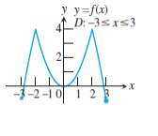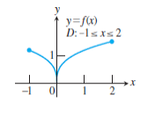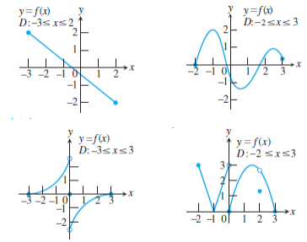

*Add and Subtract are piece of cakes, Multiply and Divide like piece of …. non-cake.*

*Product Rule $\frac{d}{dx}(uv)=u\frac{dv}{dx}+v\frac{du}{dx}$ or the notation (uv)' = u'v + v'u*

*Quotient Rule $\frac{d}{dx}(\frac{u}{v})=\frac{v\frac{du}{dx}-u\frac{dv}{dx}}{v^{2}}$ or $(\frac{u}{v})'=\frac{u'v-v'u}{v^{2}}$* ***lo di hi – hi di lo all over v square***

Find the derivative of y = (x4)(cos 6x) y ' = (x4)' (cos6x) + (x4)(cos6x) '

= _______ (cos6x) + (x4) _______

Find the derivative of y = (3x – 8)7 (4x + 9)5 and simplify

Find the derivative of y = (x2 + 1) (x3 + 3) and simplify

Find the derivative of f(x) = (x3 − 4x2 )ex cos x.

Find the derivative of y = x3(5x – 2)4sin 6x

Find the derivative of y = 4sin(3t)cos(5t) both ways

Let y = uv be the product of the functions u and v. Find y'(2) if

u(2) = 3 u'(2) = -4 v(2) = 1 and v'(2) = 2

$f(x)=\frac{sin5x}{8x-3}$ $f'(x)=\frac{(sin5x)'(8x-3)-(8x-3)(sin5x)'}{{(8x-3)}^{2}}$ = $\frac{(?)(8x-3)-(?)(sin5x)}{{(8x-3)}^{2}}$

Find the derivative of $y=\frac{{(5x-2)}^{7}}{{(4x+9)}^{3}}$

Find the equation for the line tangent to the curve $y=\frac{x^{2}+3}{2x}$ at the point (1, 2). Graph them

Let y = u/v be the product of the functions u and v. Find y'(2) if

u(2) = 3 u'(2) = -4 v(2) = 1 and v'(2) = 2

The reaction of the body to a dose of medicine can often be represent by an equation of the form

$R=M^{2}(\frac{C}{2}-\frac{M}{3})$ where C is a positive constant and M is the amount of medicine

absorbed in the blood.

If the reaction is a change in blood pressure, R is measured in millimeters of mercury.

If the reaction is a change in in temperature, R is measured in degrees, and so on.

Find dR/dM. This derivative, as function of M, is called the sensitivity of the body to medicine.

*(Source: Mathematical Models in Biology)*

Let f(x) = x4 – 4x2.

a. Find all the points where f has horizontal tangents.

b. Find an equation of the tangent line at x = 1

c. Find an equation of the normal line at x = 1 (normal line is perpendicular to tangent line)